CS 255 System Design Document Template
Brian Behrens

UML Diagrams

UML Use Case Diagram
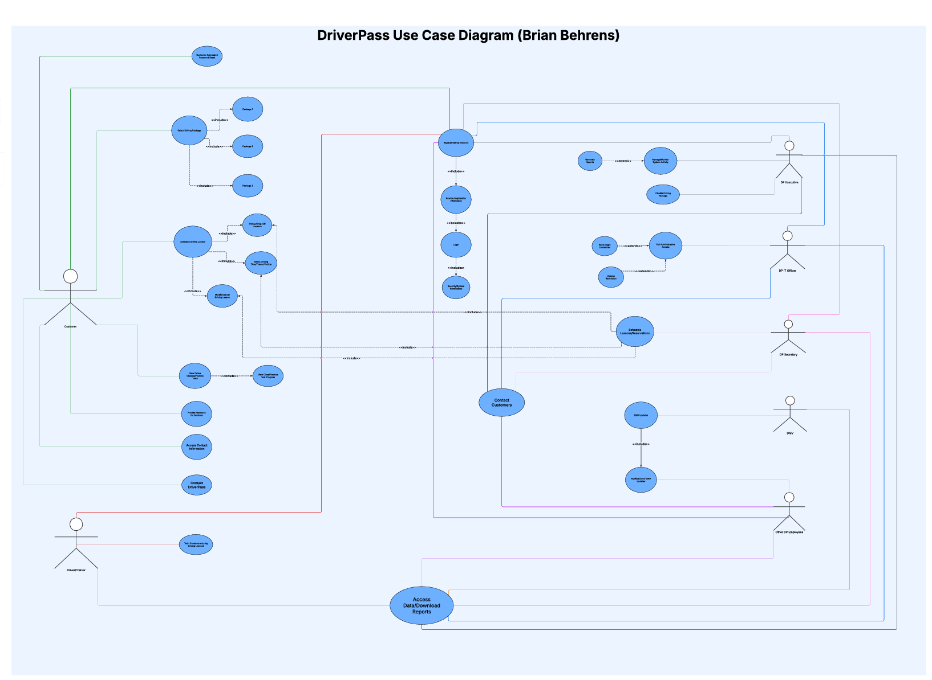

UML Activity Diagrams
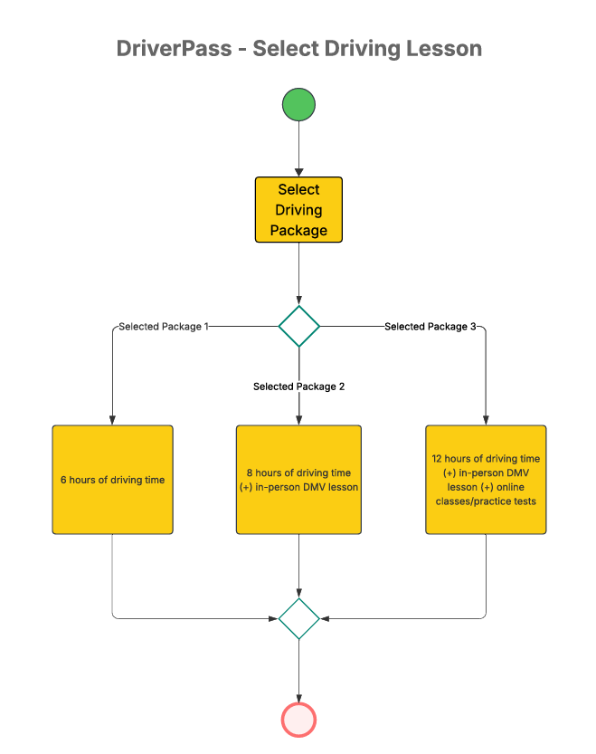
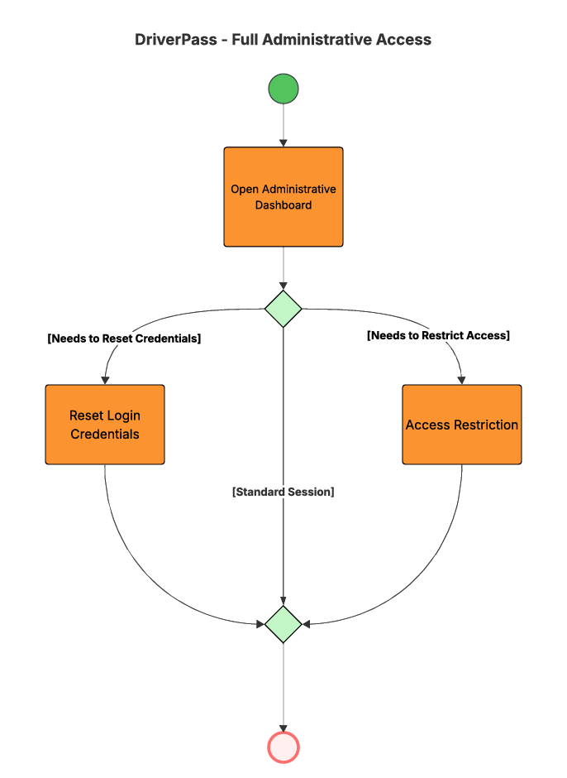

UML Sequence Diagram
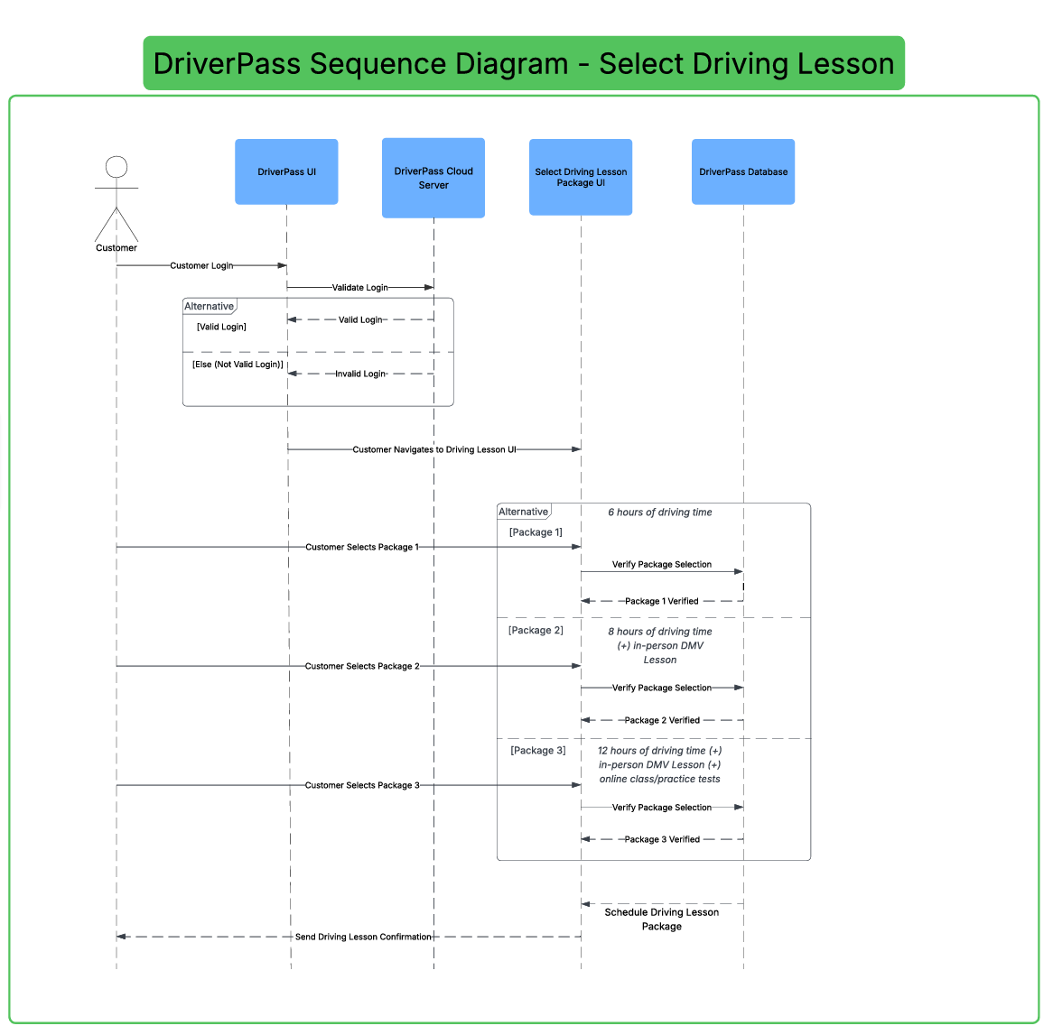

UML Class Diagram
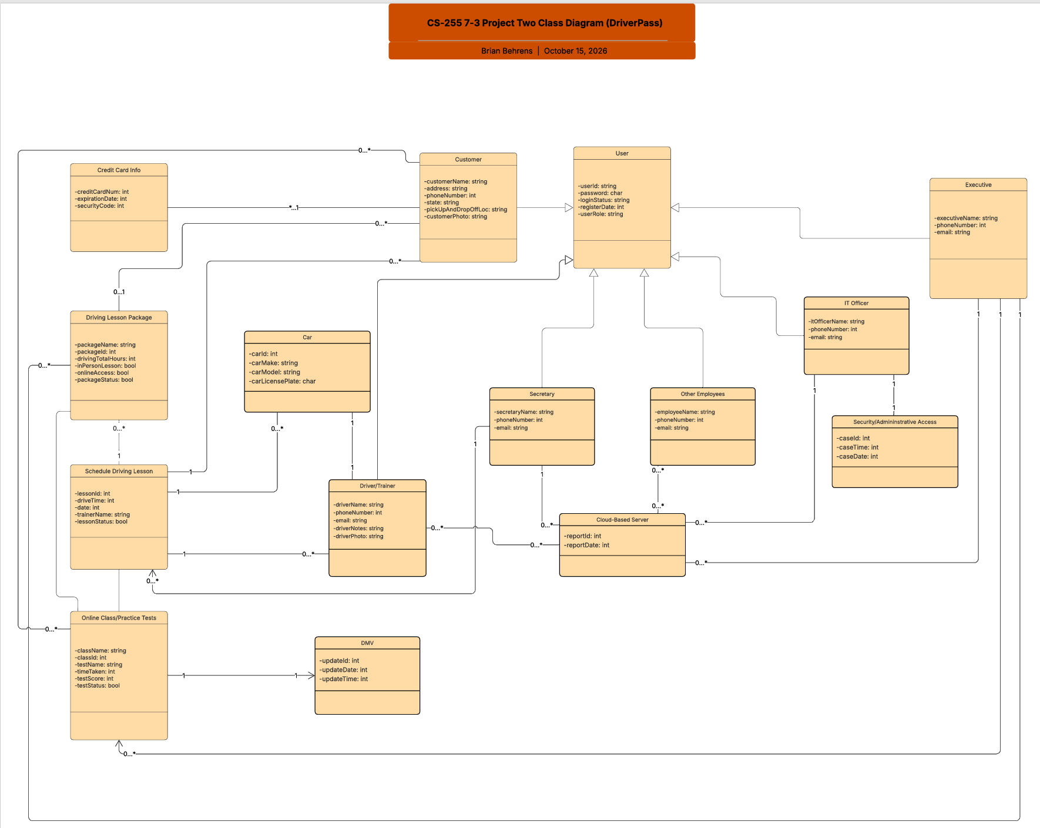

Technical Requirements
The hardware for the system will require cloud servers and any web devices that can access the internet with supported browsers. The infrastructure for the system will require a cloud-hosting environment, network connectivity, security, and database storage.

The software for the system will require a web-based application and database software to manage user accounts, customer information, lesson schedules, and educational material. The tools for the system will require software development and testing tools to build and test the system. Also, tools to manage the database as well as tools to troubleshoot any system problems.

